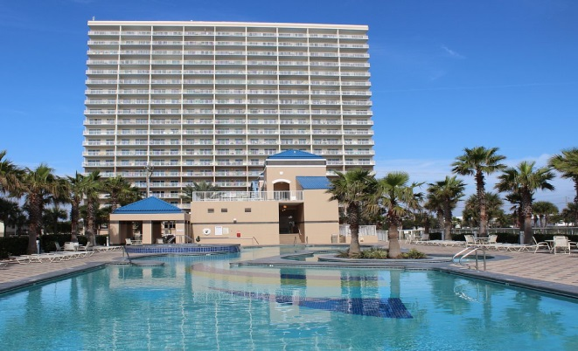
Crystal Tower 2009
1010 West Beach Blvd
Gulf Shores, Alabama
Joe@CoastalGreenAir.com
www.CoastalGreenAir.com
251-967-2111

Report on Coastal Green Air Products in CT 2009

The following equipment is now installed in CT 2009:
- The iPachie™ Thermostat with Advanced Occupancy Detection.
- The Thermonator™ water heater controller.
- The WaterGate™ whole condo water cutoff device.
- Several WaterGate™ sensors.
- Several Temp$aver™ DoorMinder™ devices on entry door and sliding glass doors.

The following is a conceptual description of the Coastal Green Air (CGA) system, presented in what I hope is the most logical sequence. For detailed specifications, please see the web site at www.coastalgreenair.com, or contact CGA at 251-967-2111.

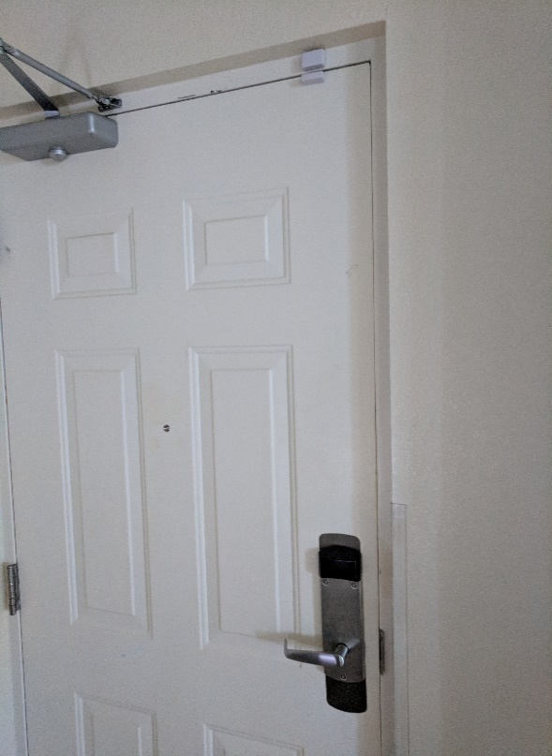
- Here is the entry door sensor. When the unit is unoccupied, opening the entry door signals the system someone has entered. This causes the water control valve to turn on, the water heater power to turn on, and the HVAC to begin bringing the temperature to the previous setting left by the last person in the unit. The guest can adjust the temperature further if desired.

The entry door sensor is also a door minder and will signal the system any time the door is left open. Therefore, if guests leave the door open for over two minutes, the HVAC will shut off until the door is again closed, to save on your electricity.

Below is a close-up of the entry door sensor.
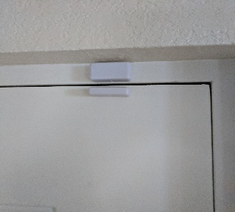

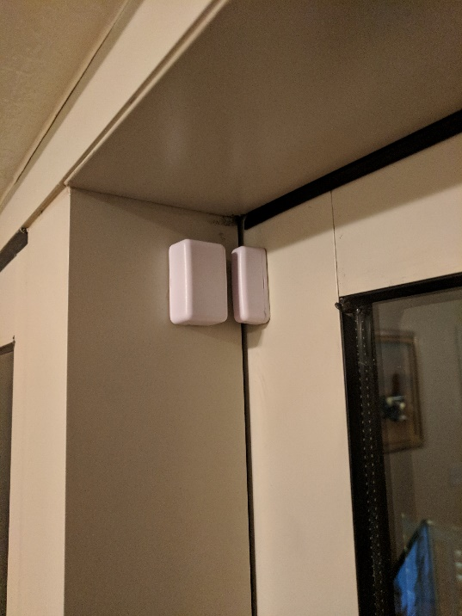
Here is a door sensor on a patio door. Each door minder allows the guest to leave the door open for two minutes, after which, the HVAC will turn off until it is again closed, saving tremendously on electricity! This will also eliminate the HVAC freeze-ups caused by this. And... it is certainly not uncommon for balcony doors to be left open for hours at a time. With the CGA system, your HVAC is not trying to cool or heat the entire outdoors!

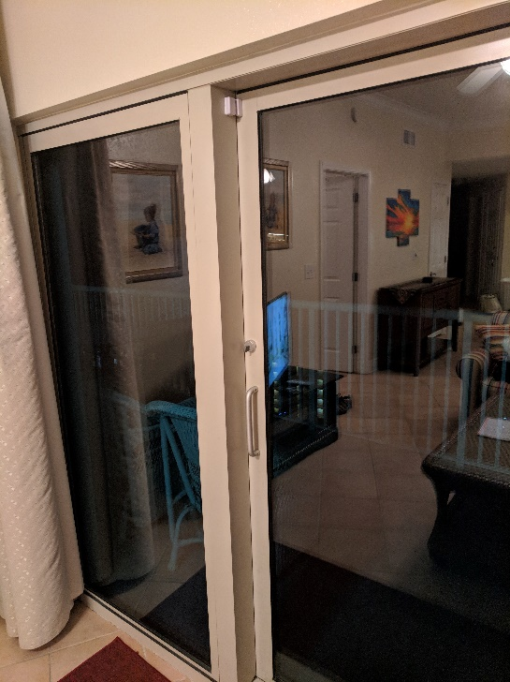

As you can see, the sensors are fairly inconspicuous, as shown in this picture.

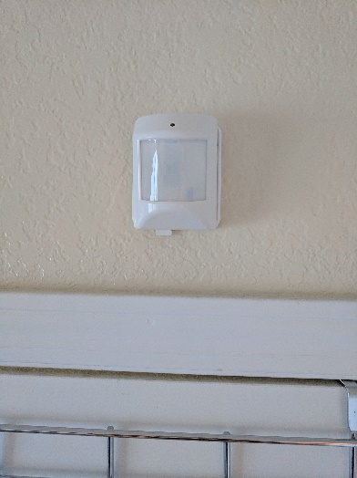
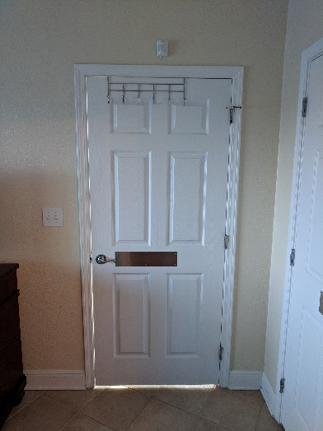
This condo has two more occupancy sensors, one in each bedroom, just to make sure that the condo water valve turns on (if it was off) when there is movement from the bedroom to the bathroom. The master bedroom sensor is shown here.

Now, here is what you’ve been waiting to see: The whole condo water shutoff valve.
As unit 2009 is on the top floor, this will prevent a leak to dribble (or worse!) down 19 floors!

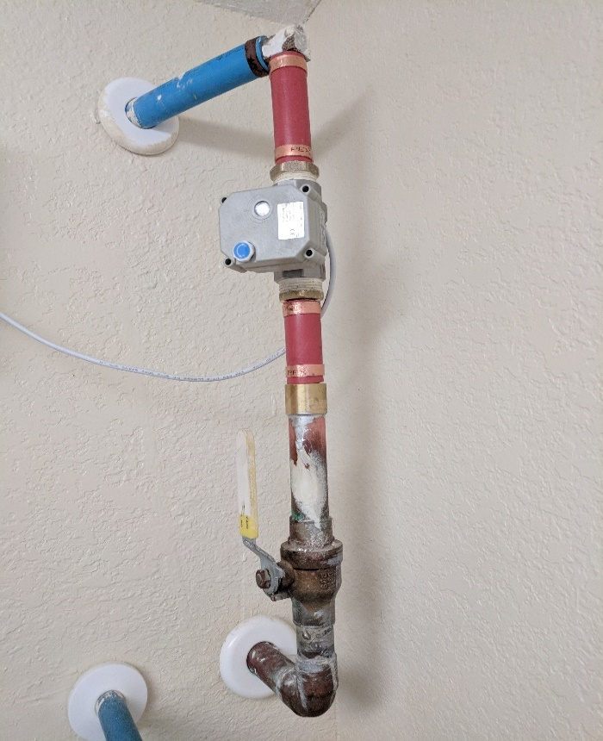
Note that in this picture, the main water service to the condo enters at the bottom, in the copper pipe. The manual shutoff valve is just above it, and the water flows upward through the WaterGate™ valve, then into the plastic pipe and from there throughout the condo. The wire goes to the Thermonator™, which is mounted nearby.

Installation was straightforward. The plumber cut out a section of plastic pipe, sweated on the lower connector, and completed the piping with red plastic pipe.

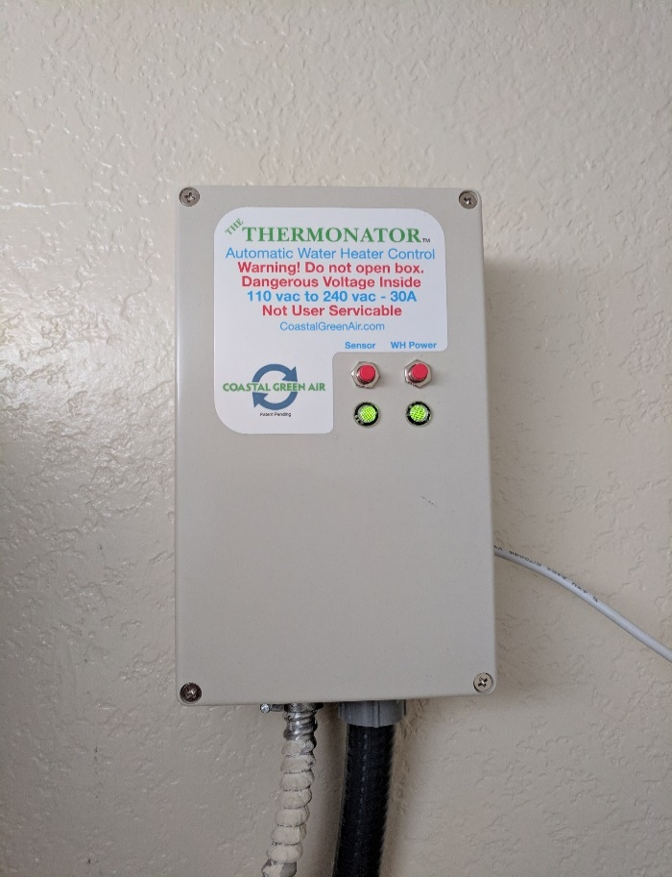
To the right is the new Thermonator™.
It receives electrical power from the 220v water heater line (the conduit on the left), and provides power back to the water heater (the conduit on the right) and the WaterGate™ (the white wire on the right).

Operation of the Thermonator™ is controlled by occupancy signals from the occupancy sensor in the iPachie™ and the door monitors.

When the condo is unoccupied, the Thermonator™ closes the WaterGate™ valve and turns off power to the hot water heater. However, the water stays hot for days, and normal temperature is quickly restored when occupancy resumes.

“Unoccupied” means that none of the occupancy sensors detects movement for a pre-set period. In Crystal Tower unit 2009, the period is set to 14 hours, but it can be much less if desired. A side benefit is that the valve gets exercised every so often so that it does not get clogged with deposits from the tap water and get stuck in position.

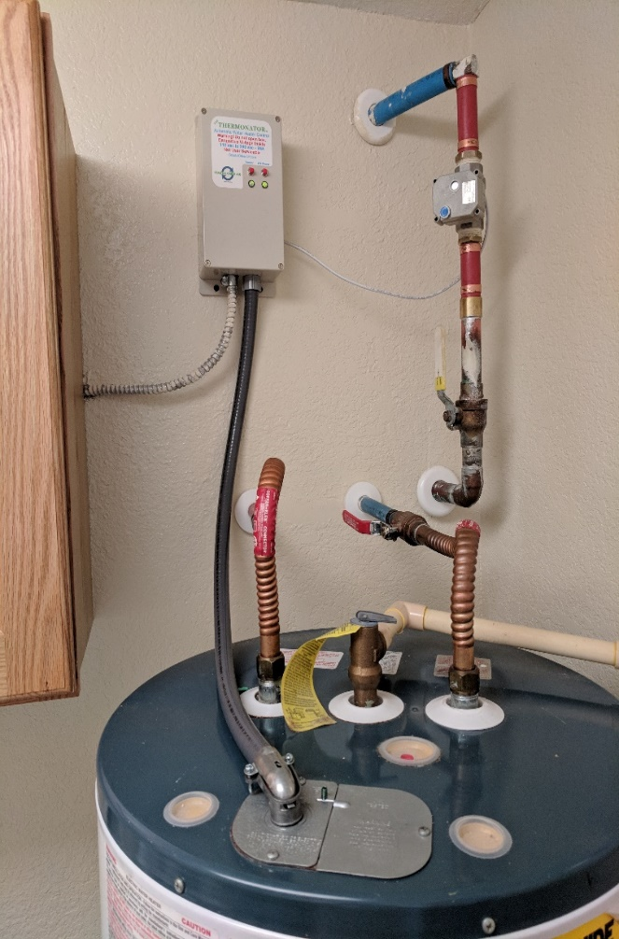
Here is a picture of the entire assembly.
Again, installation was straightforward. The conduit coming out from the cupboard on the left originally attached to the water heater. The plumber detached it from the water heater and connected it to the Thermonator™. He then connected new conduit to the water heater in the same location as before, and ran a wire from the Thermonator™ to the WaterGate™. Other than the section of pipe removed to install the WaterGate™, none of the piping was disturbed.

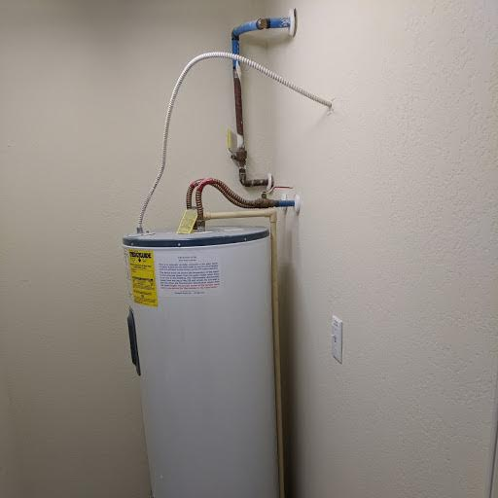
You may know that the water heater location is different in the end units like 2009, than in the interior units. Here is a picture of the water heater in 2008. You can see that installation of a Thermonator™ and a WaterGate™ in an interior unit would be very similar to that done in 2009.

So what happens if there is a leak, say from the washing machine, the dishwasher, the ice maker, or fridge water dispenser? These are all common fear factors.
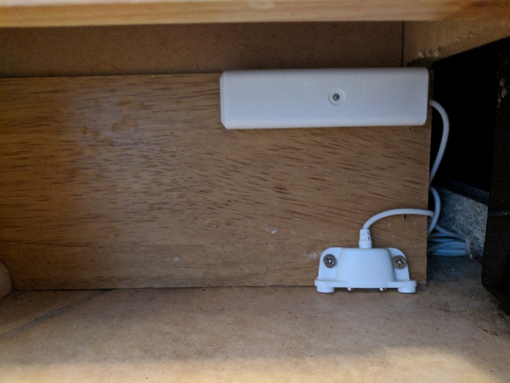
Here is a water sensor. This one is beside the dishwasher. Note there are two metal contacts that almost touch the floor, and a white box containing a battery and signal transmitter. If the dishwasher leaks, the water closes the contacts, and the transmitter sends a signal to the iPachie™, which signals the Thermonator™, which signals the WaterGate™ to shut off the water to the condo. The batteries last over two years.

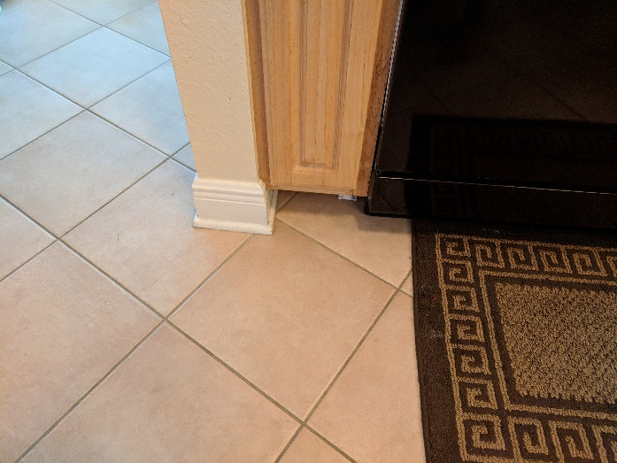

Here is the cook’s-eye view of the water sensor.

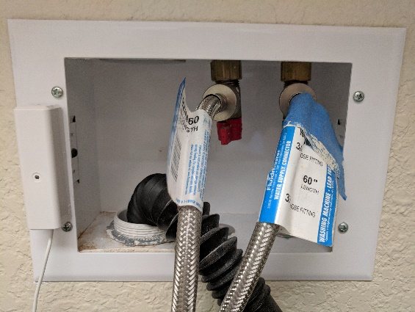

Transmitter near the washing machine, and the sensor behind it, pictured on the right.

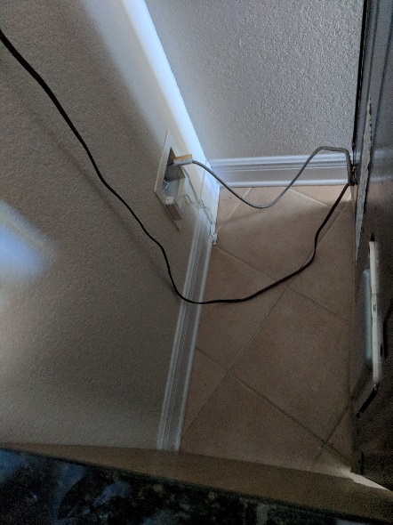

And another one behind the fridge.
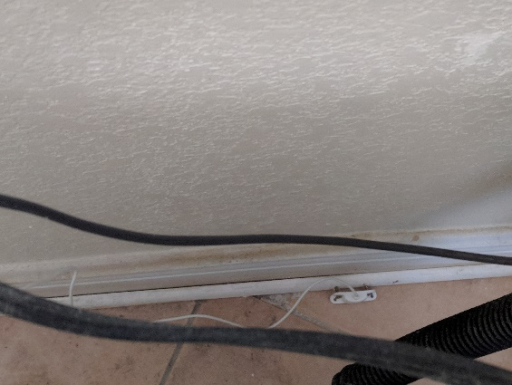

Finally, here are the brains behind it all, The iPachie™ Thermostat with Advanced Occupancy Detection.
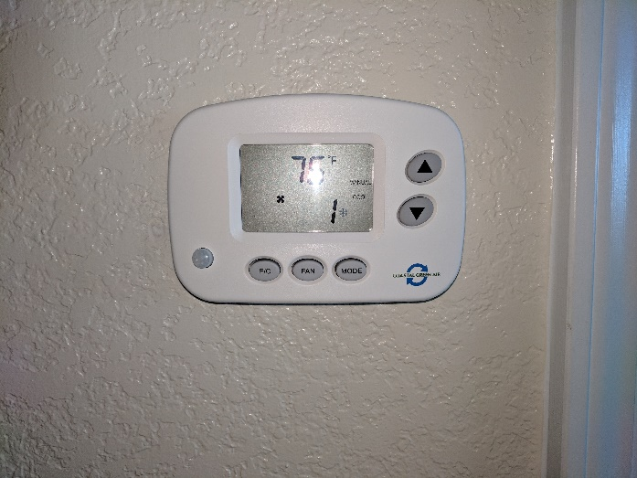
The iPachie™ controls various functions including limiting guest room temperature settings, allowing only what is comfortable and no more. It has a built in occupancy sensor, and also receives signals from any other occupancy and/or water sensors.

When the unit is not occupied, the iPachie™
will moderate temperatures in accordance with pre-set energy saving modes. It can also send occupancy signals to the Thermonator™.
The iPachie™ is wired to the HVAC unit, and both transmits and receives RF signals to and from the other devices throughout the condo.

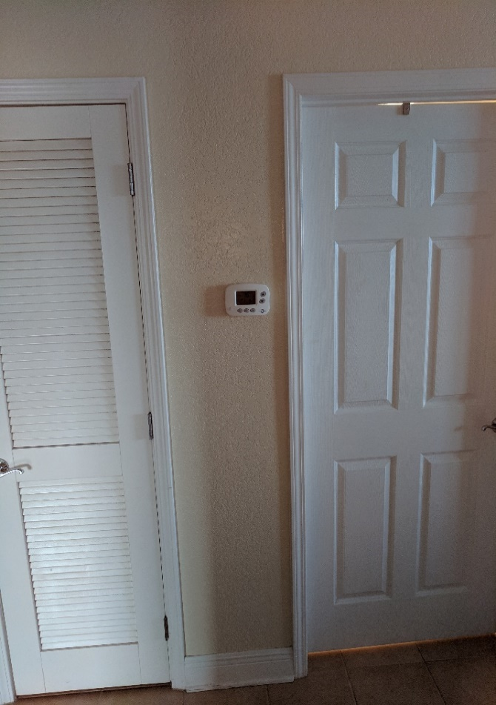
The iPachie™ replaces the original thermostat. Guest temperatures are set by the up and down arrows and the mode button selects heat or cool; all other functions are automatic

The iPachie™ includes Advanced Occupancy Detection (AOD). AOD senses occupancy through the entry door sensor(s). But what's important is what the iPachie™ does with the information. In addition to sending signals to the Thermonator™ and the WaterGate™, the iPachie™ also moderates the indoor temperatures when guests are gone 6-8 hours a day, moving first into the Away, then Hold, and finally, into Vacant mode, using timers. Each mode has progressively more energy saving temperatures to save unnecessary use of heating and cooling power while they are gone. Yet, when guests return and open the entry door, the AOD senses occupancy and returns to the guests previously set temperature. This means when the property is not in use, your systems are maintaining energy saving temperatures... Automatically! Not only this, but the iPachie™ causes the HVAC to run in Fan Mode every each hour for two minutes, helping to prevent cold or hot spots due to stagnant air, possibly causing mold growth. All iPachie™ operating parameters are arbitrary and may be changed. In addition, it also has a VIP pass code which allows owners to both override any rental settings when they wish to stay in the unit and which will protect all internal settings of the iPachie.

Coastal Green Air, Inc.
3817 Gulf Shores Pkwy, Suite 1
Gulf Shores, AL 36542 - 251-967-2111

